Web Design Project Report





|  |  |
| --- | --- |
| Project Team | |
| Student No. | Student Names |
| x19139306 | Rory Cleary |
| x19175108 | Geneci Ui Fhátharta |
| x19176414 | Kasia Casserly |

**Cakes & Treats by Daniella**

[**www.cakestreats.com**](http://www.cakestreats.com)

[**www.cakesandtreats.gear.host**](http://www.cakesandtreats.gear.host)

Contents

1 Project Overview 4

1.1 Our Client 4

1.2 Project Motivation 4

1.3 Project Goals 5

1.3.1 Major Goal 5

1.3.2 Specifics Goal 5

2 Section 1: Design 5

2.1 Research / Investigation 5

2.1.1 Company 1 5

2.1.2 Company 2 5

2.1.3 Company 3 6

2.2 Client Requirements 6

2.2.1 Functional Requirements 6

2.2.2 Non-functional requirements 6

2.3 Challenges 7

2.3.1 Expected Challenges 7

2.3.2 Unexpected Challenges 7

2.4 User Case 8

2.4.1 Use Case Diagram 8

2.4.2 Use Case Scenario 8

2.5 Technical Approach 9

2.6 Sitemap and Wireframe 9

2.6.1 Sitemap 9

2.6.2 Wireframe 10

3 Section 2: Development 11

3.1 Prototype 11

3.2 Decision on codes: 11

3.2.1 HTML 11

3.2.2 CSS 11

3.2.3 JavaScript 11

3.2.4 Colour Scheme 11

3.3 Validation and Errors 12

4 Section 3: Deployment 12

4.1 Choosing the hosting company 12

4.2 Cakes and Treats Live 12

5 Section 4: User Testing 12

6 Section 5: Project Team 12

7 Section 6: Conclusion 13

7.1 Aims 13

7.2 Lessons Outcomes 13

7.3 Skills Gained 14

7.4 Conclusion: Still to improve 14

8 Section 6: References 15

# Project Overview

This project is the result of one semester of studies of the subject Web Design. We were requested to plan, design, develop, test and deploy a website of our own choice.

We chose to work with a client who wanted to have a website to show the cakes and treats that she designs.

As a group we accepted the challenge and worked hard in order to deliver a final product that would represent the groups' ability to work together and also to showcase all the knowledge and skills that we have acquired as a result of the subject taken during this semester.

Several meetings were held in order to understand the meaning and the level of services needed to be delivered at the end of the project. A set of rules were defined in order to direct the project. Major and specific goals were demarcated.

As a group we set five clear interim deliverables:

Deliverable One: Find a client and define the Website type – 11/10/2019

Deliverable Two: Gather all requirements and decide on Website Wireframe as well to have a prototype in place based on user case. – 25/10/2019

Deliverable Three: Develop and Test the Website. – 22/11/2019

Deliverable Four: Deploy the Website. – 25/11/2019

Derivable Five: Submit the project. – 05/12/2019

## Our Client

Our client is a passionate cake maker. Her name is Daniella Garau who requires a website to display all the beautiful and amazing cakes that she designs and bakes. Daniella has a variety of products and now wishes to branch out and produce, a line of vegan products, to attract the audience of this community and to broaden her horizons.

## Project Motivation

When our group decided to go with the website project for Daniella, the main motivation was that she wished to have a simple website and as we are new to website exposure, we felt this was an opportunity to demonstrate that we could undertake this project and build the website.

## Project Goals

As this is part of our learning outcome for a college subject, our main objective is to demonstrate that we have learned regarding HTML, CSS, JavaScript and the design process itself.

### Major Goal

Our major goal is to provide a functional website where our client can show her products and get requests through her email, via a web form.

### Specifics Goal

* To work well as a group and divide tasks evenly;
* To set out reachable deadlines for the necessary projects to be completed;
* To list the requirements needed to design the system;
* To fulfil the client’s needs by being able to provide them with a working website at the end of the project;
* To plan and design the website.
* To develop, test and deploy it.

# Section 1: Design

## Research / Investigation

### Company 1

Kelly Lou Cakes.

Kelly Ging, who is the owner of Kelly Lou Cakes cafés and boutique bakery in Portlaoise, Co Laois. They specialise in creating beautiful custom cakes, cupcakes and gourmet treats.

### Company 2

Mannings Bakery

Manning’s Bakery began as a small family bakery in Dublin over 60 years ago. We are experts in occasion cakes and confectionary providing everything from bespoke wedding cakes to creative confectionary with corporate logos.

### Company 3

Cakes by Lynzie

Lynzie specialises in bespoke designed cakes for weddings, birthdays, christenings, anniversary’s and corporate. She has won awards for her designs in both wedding cakes and novelty cakes.

After researching and consulting with our client, in relation to the type and the theme of the website that was required, we decided that the Cakes by Lynzie website would be a perfect template for us to get started with. We had had numerous team meetings, at this stage, and were happy to begin our development process. Our first draft was produced and subsequently redesigned, as we decided change the structure of the website.

## Client Requirements

* The website should be responsive and also compatible with all browsers and viewable on most technologies, for example desktops, laptops and mobile devices.
* Making changes to the website should be user friendly and easy to complete.
* The website should be easy for the user to use with easy navigation through the pages and consistent design and page layouts.
* A photo gallery or slide show of photos for her previous designed products.
* The website will be live for twenty four hours a day, seven days a week and will be free of charge for users to use.

### Functional Requirements

* Pages to contain links to social media pages for the organisation, for example Facebook and Twitter.
* Home page with picture.
* An easy to use website.
* An easy to use menu bar.
* An about us page which contains information about Daniella.
* A contact page with a form where visitors can request a cake and also provide Daniella with feedback.

### Non-functional requirements

* The website should be compatible with all browsers and viewable on most technologies, for example desktops, laptops and mobile devices.
* The website needs to have a fast response time and processing time for example in accessing the contact us form.
* Content from the Contact form should be directed to user provided email.

## Challenges

### Expected Challenges

The topics studied in the Web Design module were learnt key skills that could be brought forward into this project. Learning how to mix/match colours and learning basics in HTML, CSS and JavaScript were highly useful. Those skills and the group life experience are to help us with any challenge the project presents.

We developed a draft of our website coded using Bootstrap but after testing and viewing it we decided, as a group, to remove the Bootstrap elements for our code and only use code that we produced ourselves. We found this option better for our coding development.

#### Coding

The skills involved in coding were a major challenge for two group members throughout the project. We planned to divide tasks and the project part in order for all team members to make contributions and whoever had more experience, to help to raise the technical skill of all members.

#### Interpersonal

Interpersonal skills also had to be developed. These skills could only be truly developed from experience. As an online group we met frequently via Skype and also on our WhatsApp group, with work being delegated to each other. We also had to meet online with our client to outline our requirements and ensuring everyone was happy with the agreements in place.

### Unexpected Challenges

#### Hosting

One of the main challenges we faced was the purchase of the hosting, at first we thought it was going to be expensive. We discussed hosting approach at our third meeting and then decide to leave it to conclude when the website was completed. A member of the group offered to research possibilities and found a very good deal for us.

Subsequently we were made aware of a hosting site called GearHost and in conjunction with WinSCP we also deployed our website through this avenue.

## User Case

### User Case Diagram

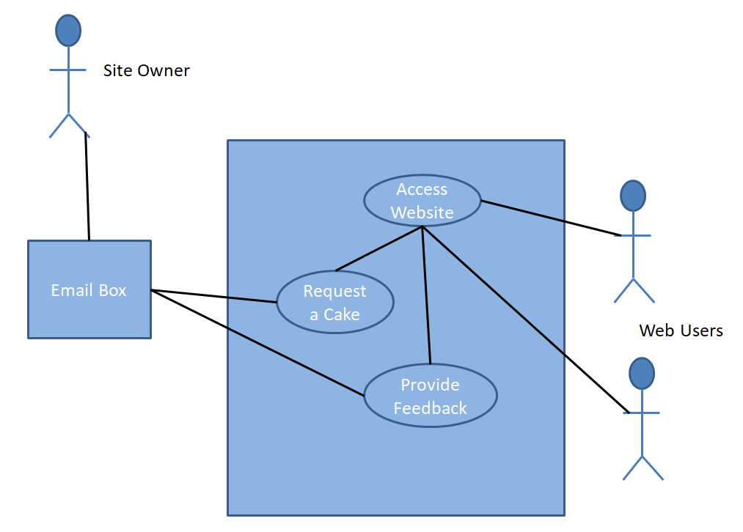

### User Case Scenario

We tried to use user case scenario based on Behaviour Driven Development (BDD) notations. For that we developed two scenarios to guide us during the development.

#### Scenario 1:

* Given: User 1 accesses Cakes & Treats website
* When: User 1 fills up a form requesting a birthday cake
* Then: Daniella receives an email about request and the User 1 contact details.

#### Scenario 1:

* Given: User 2 accesses Cakes & Treats website
* When: User 2 fills up form providing feedback
* Then: Daniella receives another email with the User 2 details.

#### Scenario 1:

* Given: Daniella accesses Cake & Treats backend
* When: Daniella opens any page files
* Then: Daniella is able to make change to the website.

## Sitemap and Wireframe

### Sitemap

The site Map consists of a home page that links to all others 5 pages.

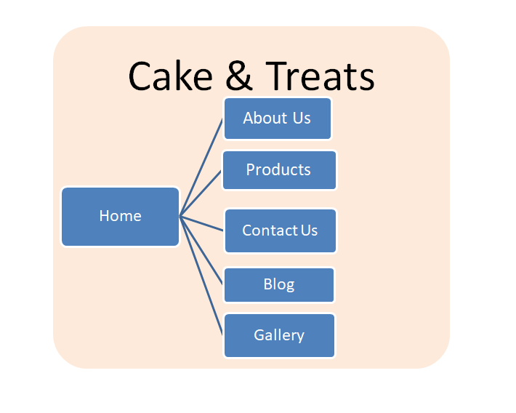

### Wireframe

#### Chosen Wireframe

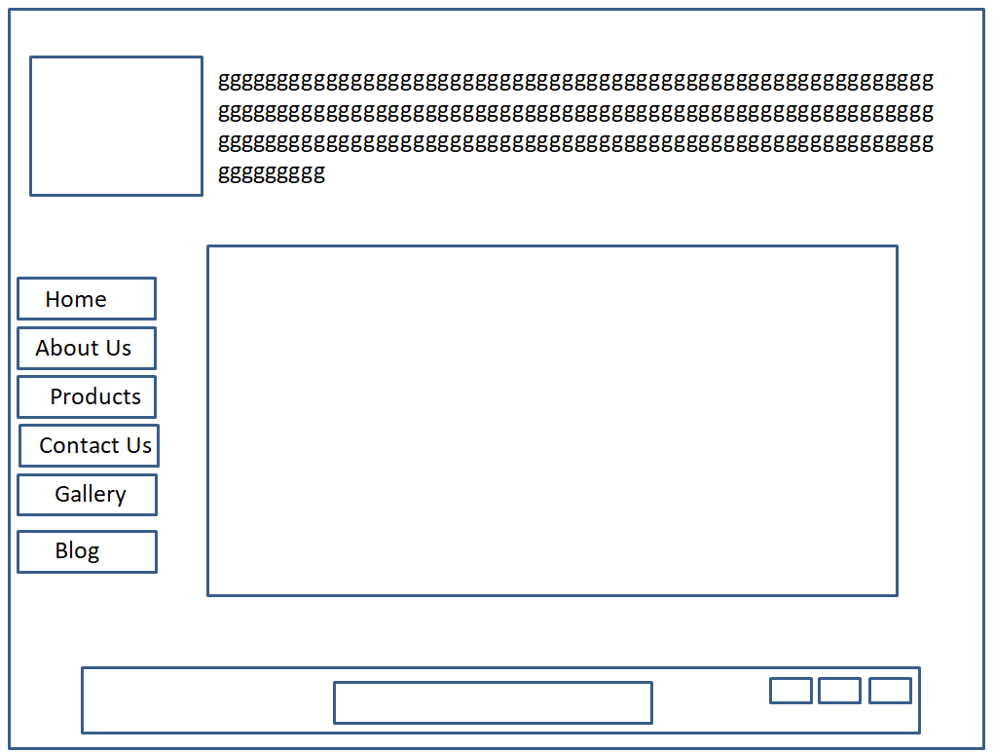

#### Suggested Wireframe

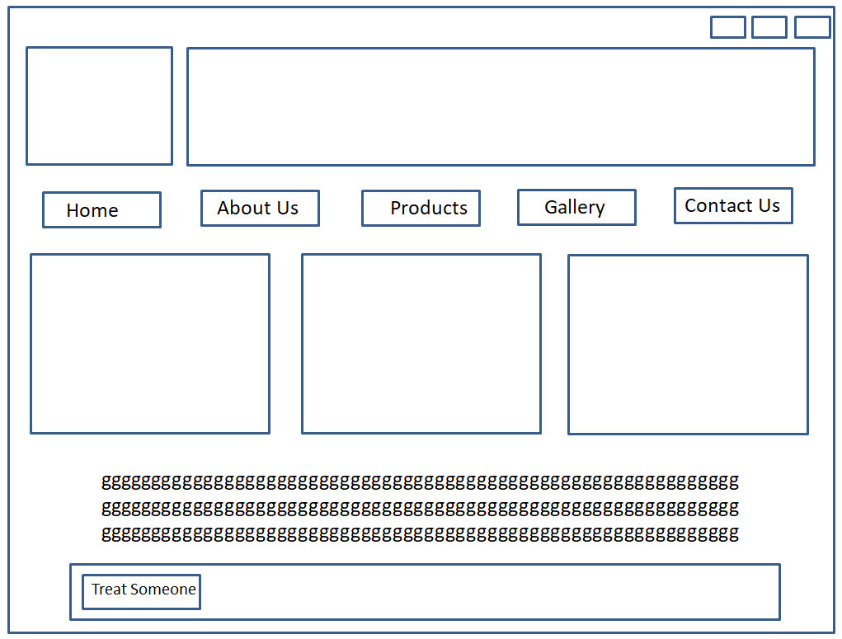

# Section 2: Development

## Prototype

The website began with a first draft which included slightly stronger colours and the logo sitting in the middle of the page. It was subsequently changed to the present version as we felt that the logo would fit better on the left of the page, as is the recommended practice for viewing, and the colours were toned down a few shades. We felt that this redesign took our project to the next level and it made it a more professional looking website.

Our first screenshot shows an early design for our site and the second screenshot shows our final screenshot of the site as it is currently.

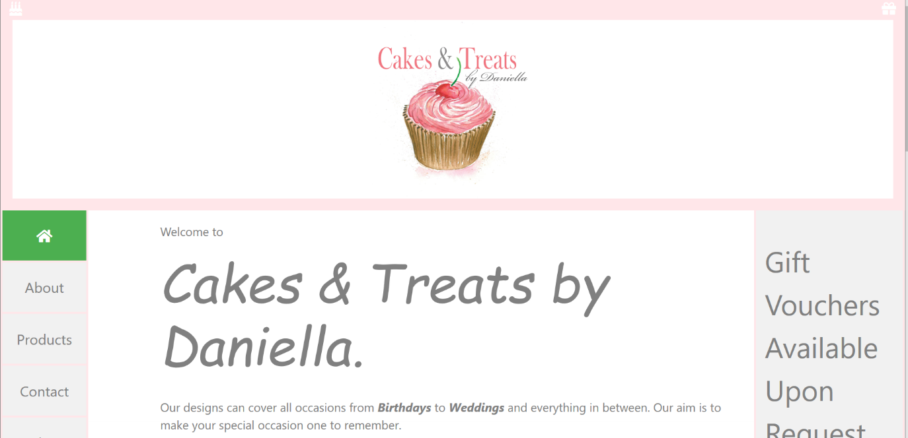

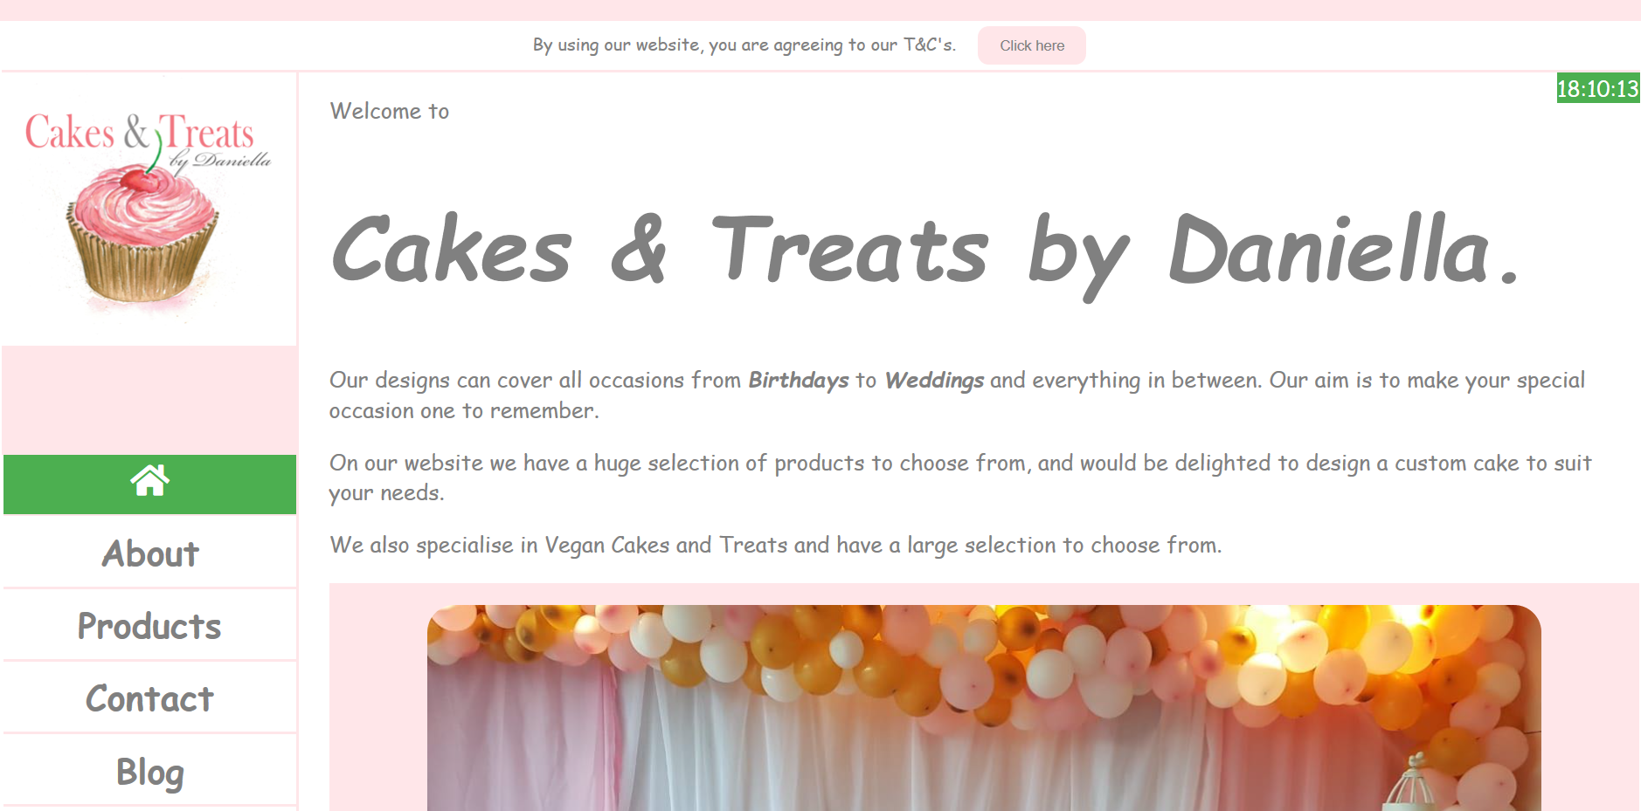

## Decision on codes:

As a team we were more than happy to change or alter the source code of all the files as we seemed fit but it was noted that we must show our changes to the other members before any code was committed to a master file. For this purpose we set up a GitHub account for our project and all our source code was placed in here for us to view and offer a change if we so wished.

### HTML/ CSS/JavaScript

[www.cakestreats.com](http://www.cakestreats.com) is developed and coded from scratch. We stayed away from templates of any kind as we wanted to produce a website which reflected our hard work and advancement from the beginning of this module to the present. Only code that has been taught to us, during the module, has been allowed into our project, as we all agreed from the start that we wanted this project to be our work and not use another’s code. There are 6 pieces of CSS code and 1 piece of JavaScript code that we copied from the w3schools website. Everything else is all coded from our own endeavours.

In our design meetings in relation to getting the website to be responsive, after much deliberations we analysed our code and debugged it to finally get all pages to be able to be viewed on all devices without any loss of responsiveness.

We noticed that in order to get our website becoming responsive is the position of the navigation area when the screen size is reduced. Having considered the design elements we decided that it was actually a positive aspect of the user experience when using the site on a mobile device. The navigation area slides under the content area when the screen size is reduced but as mentioned it makes the user experience more effective this way.

We have followed all the required standards from the W3C consortium in coding our website in HTML, CSS and also the required standards for JavaScript.

The following pieces of code are the code that was used from the w3schools website:

/*code used from w3schools.com for the hover buttons, to make each nav tab active and to remove last line from nav*/

.nav li:last-child{

border-bottom:none;

}

.nav li a.active{

background-color:#4CAF50;

color:white;

}

.nav li a:hover:not(.active){

background-color:#555;

color:white;

}

input[type=text],input[type=email],input[type=tel]{ /*code used from w3schools.com for the input type buttons*/

width:50%;

}

input[type=reset]{

background-color:red;

color:white;

cursor:pointer;

margin:15px 2px;

border:none;

padding:10px 20px;

border-radius:10px;

}

input[type=submit]{

background-color:blue;

color:white;

cursor:pointer;

border:none;

margin:15px 2px;

padding:10px 20px;

border-radius:10px;

}

/*timeFunction shows the current time on the page. Code is from w3schools.com*/

var myVar = setInterval(myTimer, 1000);

function myTimer() {

var d = new Date();

document.getElementById("time").innerHTML = d.toLocaleTimeString();

}

### Colour Scheme

For colour scheme of the website we researched on the web common colours for cakes and treats website. Then we created a questionnaire with the most used 5 scheme and provided to user to choose from the questionnaire or to suggest any other scheme. The chosen colour scheme is recorded as below.

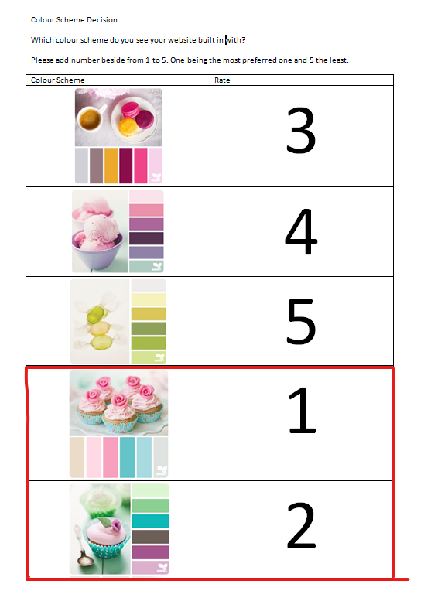

## Validation and Errors

After completing our coding for the site we used the industry standard validation tools in the form of:

HTML validator - <http://validator.w3.org/>

CSS validator - <http://jigsaw.w3.org/css-validator/>

We had only a few minor errors and these were rectified quickly and the pages were sent through the validation process, once again and all the code was deemed to be correct and validated accordingly. The pages which were showing validation errors were the index page, the blog page and the products page. Included are screenshots of the error codes and then the validation screenshots.

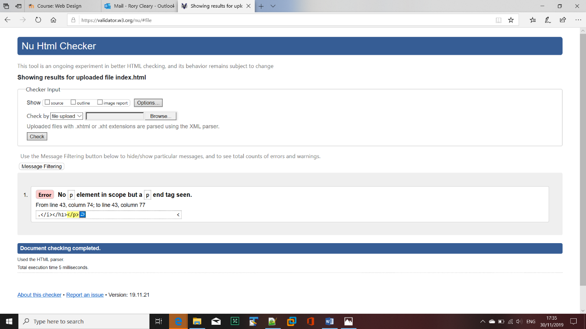

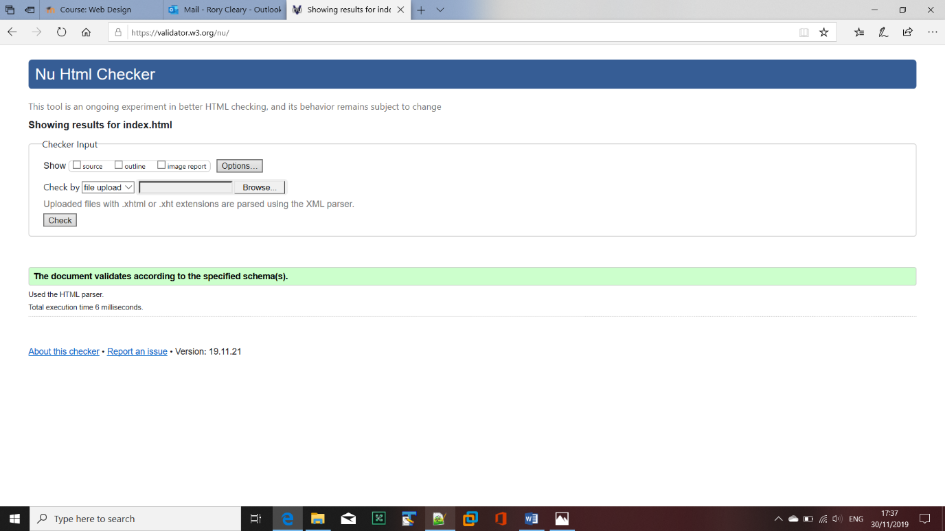

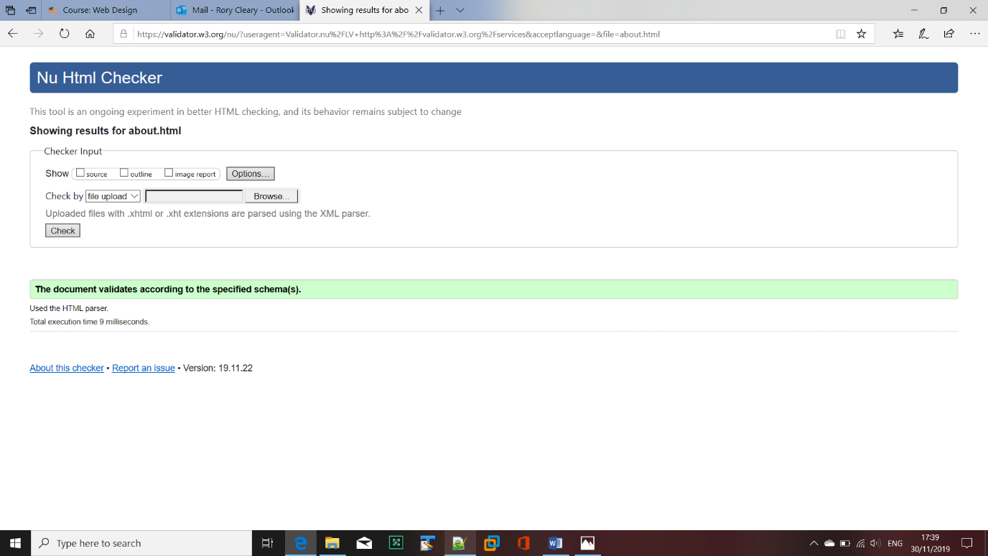

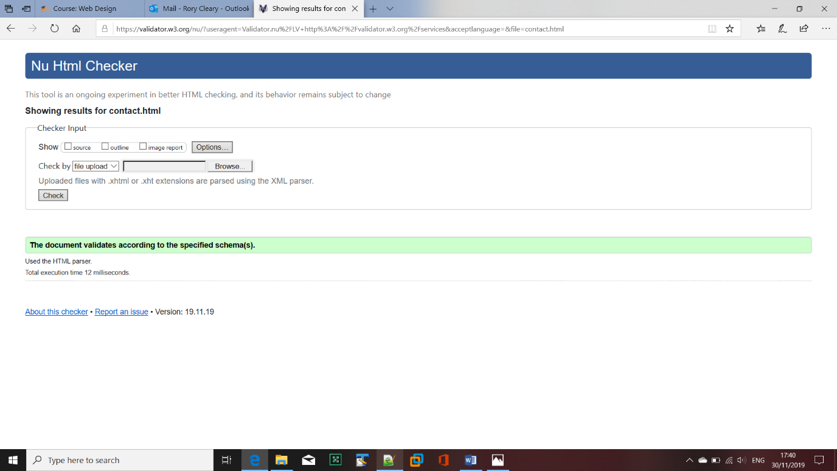

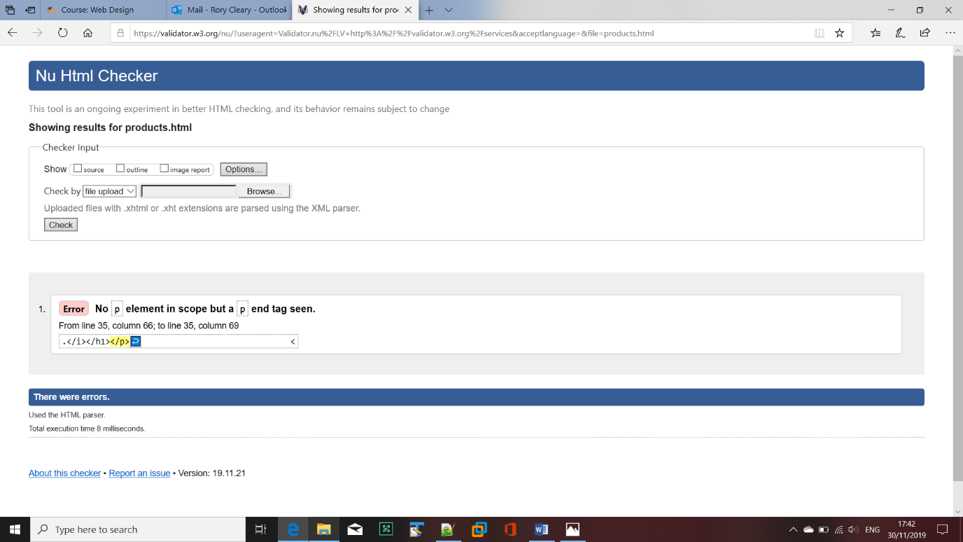

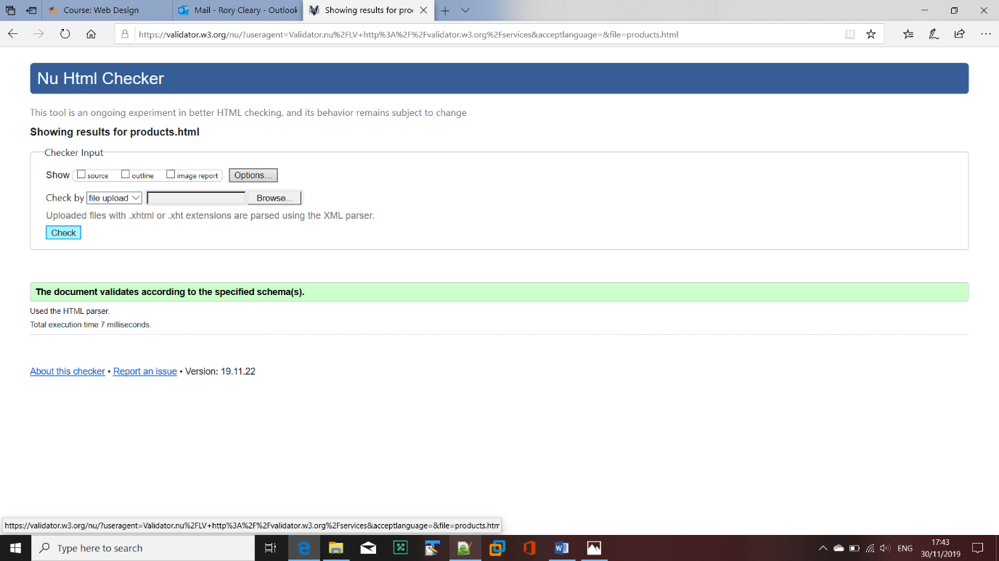

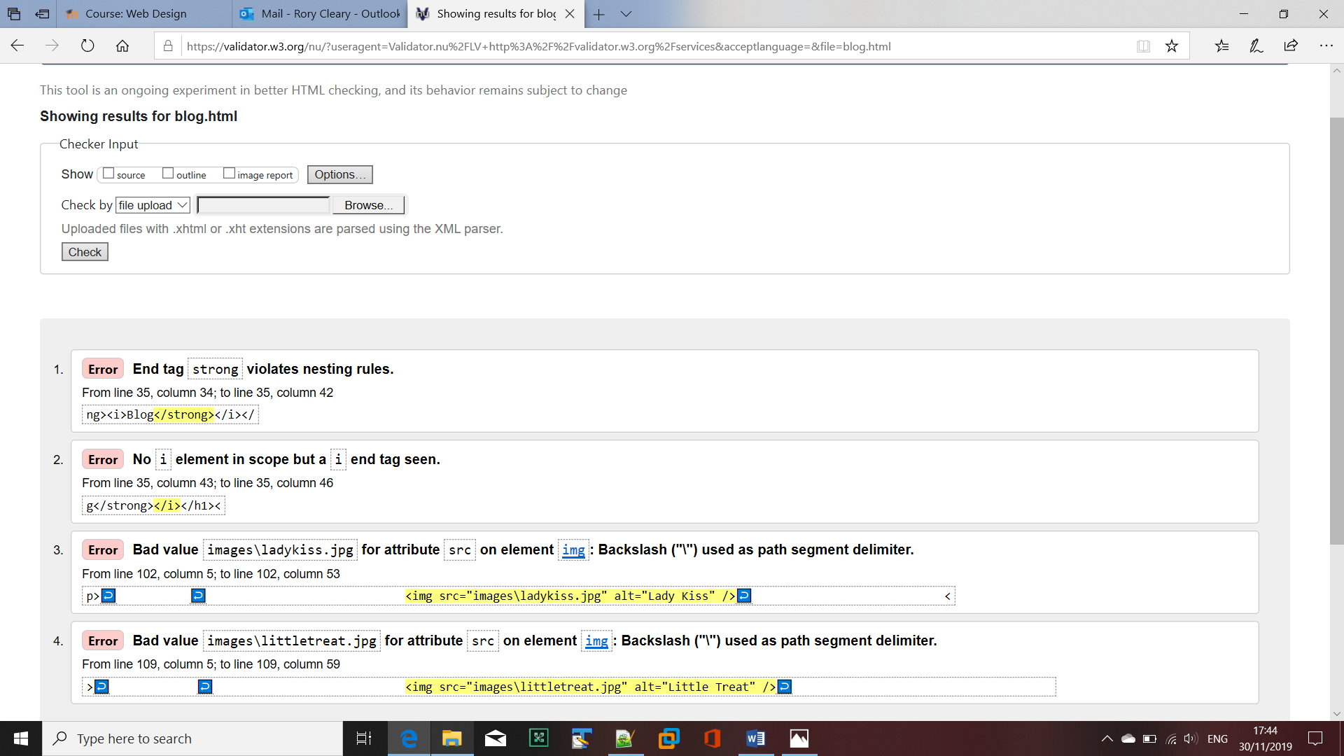

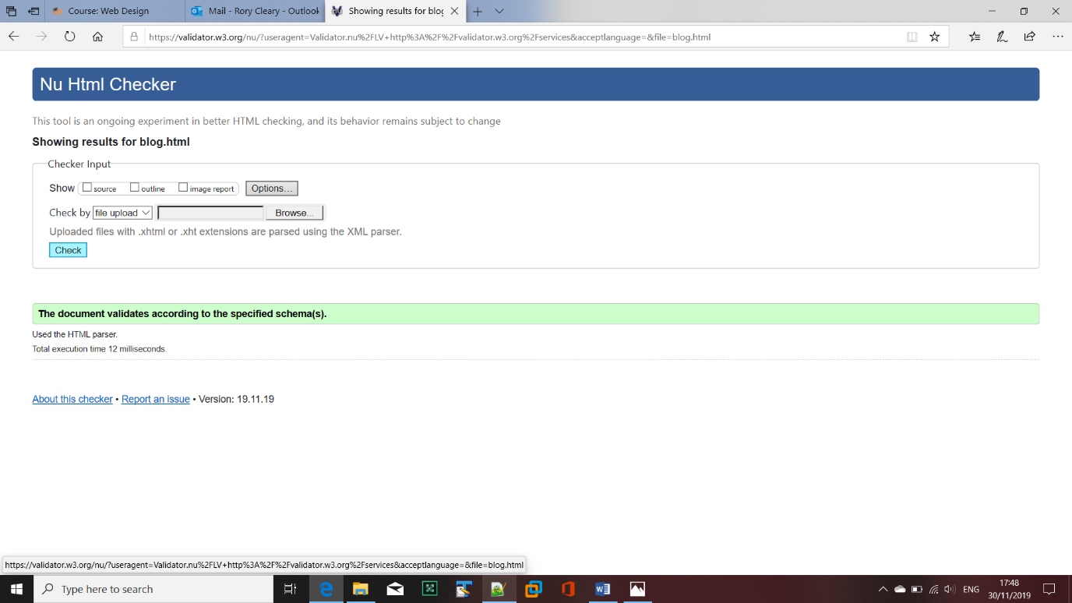

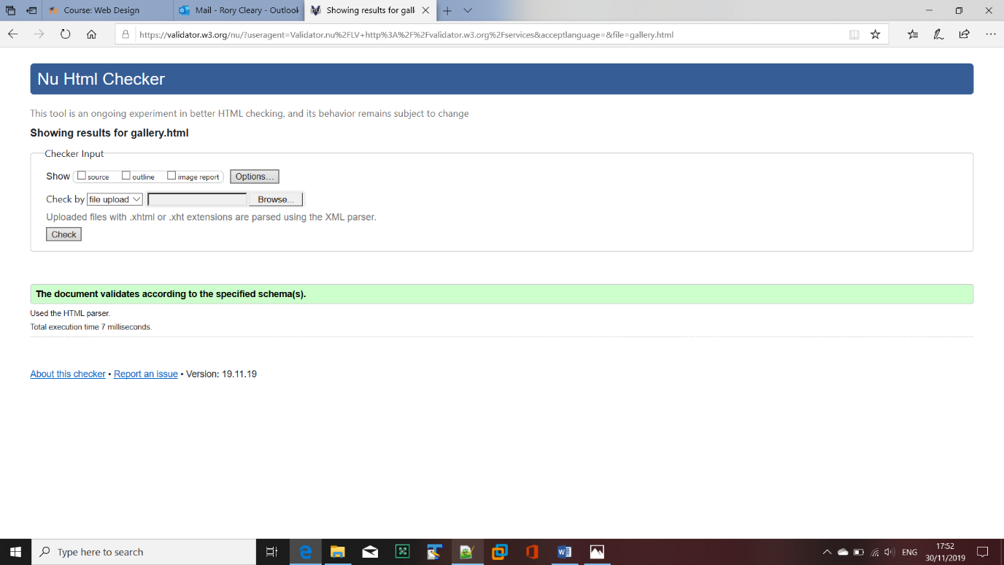

# Section 3: Deployment

## Choosing the hosting company

The hosting of the website was researched and it was decided that after reviewing our options that we would use GoDaddy.ie to host the site. We had to pay a small fee to buy the domain name and also to host the site on their servers. The Linux package was our choice as we felt that in the long term it would prove cost effective as it would provide extra security and the ability to scale the site upwards if it was required.

[www.cakestreats.com](http://www.cakestreats.com)

Subsequently we were informed, in one of our classes, of the option to host the site through GearHost and WinSCP and the site was also made live through this mechanism.

[www.cakesandtreats.gear.host](http://www.cakesandtreats.gear.host)

## Cakes and Treats Live

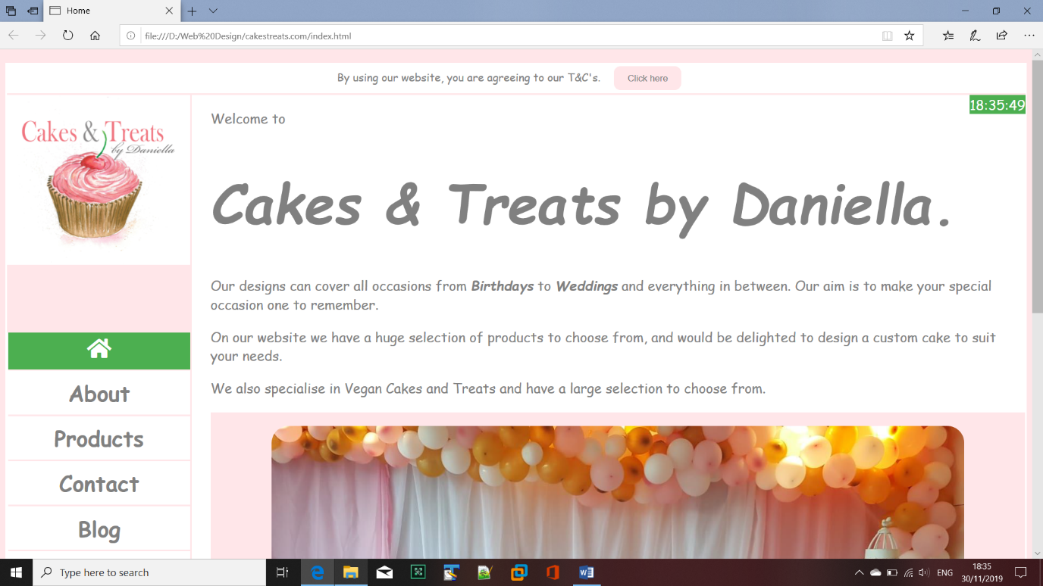

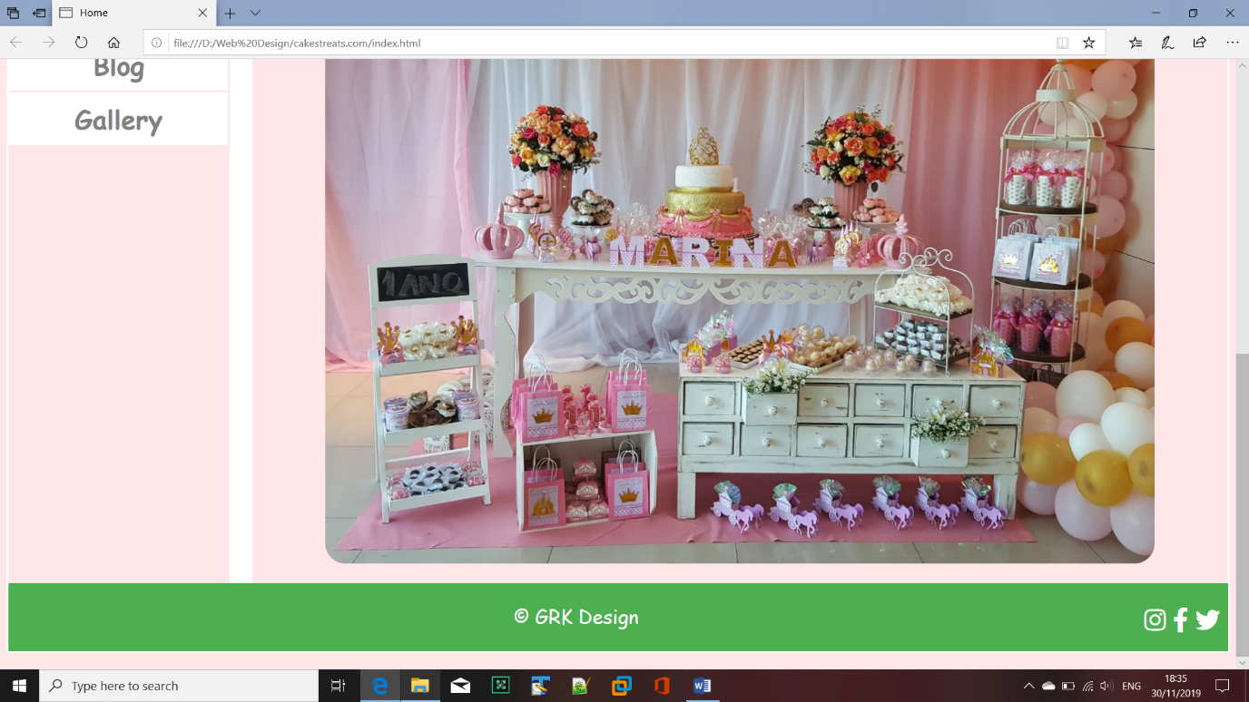

# Section 4: User Testing

There were a few stages of the testing:

1. Three users were asked to open website using different browser and devises. Feedback was that they couldn’t display correctly website on the mobile devises. Bootstrap function wasn’t working correctly. It was correctly and update coding was implemented. Users redid their testing and there was no more issues.
2. Design and functionality of the website was tested by 2 users. In the original version size of the pictures in the blog were significantly smaller. It was suggested to increase size of the pictures to improve transparency of the page. Once pictures size was changed. There was no more comments regarding website design.

# Section 5: Project Team

Each team members was assigned the task and Rory Cleary was the team leader. He was coordinating the project and making sure everything was delivered on time.

Task breakdown:

Geneci Ui Fhátharta – prepared Product and Gallery pages

Kasia Casserly – prepared Blog and About page

Rory Cleary – prepared Home and Contact page

Each member of the team tested other member pages and gave feedback and comments.

The main issue team faced, was the time management. Knowing December will be very busy with CAs and other projects, it was decided from the beginning to complete project by the end of November. There were agreed a strict deadline to deliver each part of the work to make sure everything is completed on time. Team was meeting regularly to monitor progress of the project and to discuss production problems faced by each team members.

Overall team worked very well and there was an excellent communication and support during the project.

# Section 6: Conclusion

The definition of achievements by the team could be seen from the Project success Criteria that has been identified in the early planning stage of the project, this includes:

The team analysed that:

*The success of this project will be determined by some criteria which includes;*

* That the project is able to meet all requirements as specified in the requirement section.
* That it meets the purpose, objective and satisfaction of Client and Users.
* That all deadline are targets are meet in due times stipulated by the project document and by our own team.
* That every deliverables in the life of the project meets everything to a high standard.
* There is the successful deployment of the website.
* And for the group, that all learning curves are achieved at the end of the project lifecycle.

Therefore the project achievement is been considered from the light of accomplishing the above statement under the following headings:

## Aims

* The team was able to meet the aims by delivering a fully functional website with a form for user to contact our client.
* Was able to satisfy our Client and her Users by meeting all the requirements that has been set out.

## Lessons Outcomes

The learning outcomes gained by the team members were great, we all have benefitted a lot of first hand experiences from going ahead with this project, all learning curves was achieved, from low from the early weeks and increases as the weeks went by with learning of new applications and researches from different sources.

## Skills Gained

Some of the skills gained by the members of the team include:

* Planning and Coordination skill: We have been able to acquire the skill of planning, as well as coordinating from the beginning of the lifecycle of the project till the end;
* Team work collaboration: We were able to work together on the project, using social networks such as Skype, WhatsApp, GitHub and emails to improve effective communication among members;
* Problem Solving Skills: The team learned how to identify and solve problems step by step;

## Conclusion: Still to improve

In General we are very happy with the result achieved as we were able to deliver all requirements for the website in both level: from the project point of view and also from the client perspective.

Our team had a clear vision of work with we were comfortable with due to the scope and time of the project. Saying that, we as team, believe that the website could have some improvement to better serve the client needs in the future. For example our client could ask for a database to be designed so that she could better administrate orders and feedbacks from users.

# Section 6: References

FormGet. 2015. HTML CSS. [ONLINE] Available at: <http://www.formget.com/category/html-css/>.[Accessed 25 October 19].

Navigation Buttons. 2019. W3Schools. [ONLINE] Available at:

<https://www.w3schools.com/css/css_navbar.asp> [Accessed 10 November 2019].

Time Function. 2019. W3Schools. [ONLINE] Available at:

<https://www.w3schools.com/js/js_timing.asp> [Accessed 14 November 2019].

Input Buttons. 2019. W3Schools. [ONLINE] Available at:

<https://www.w3schools.com/js/js_timing.asp> [Accessed 17 November 2019].